Conference dates

SYD also includes attendance at CMF’s national Students Conference, where delegates will join about 400 medical students from across the UK and Ireland, for the weekend. The itinerary for the week is outlined below:
SYDENHAM INTERNATIONAL
4th-9th February 2018
CMF Office, London
Sunday 4th February | Arrival
Monday 5th February
Tuesday 6th February
Wednesday 7th February
Thursday 8th February | CMF STUDENT CONFERENCE  9th-11th February 2018  Swanwick, Derbyshire
Friday 9th February
Saturday 10th February
Sunday 11th February
Monday 12th February | Suggested Departure

London travel information

There are good transport connections from all London airports to central London, where the CMF office and the accommodation are situated. Please make your way straight to the accommodation on arrival. We assume that you are able to do this independently. If this is likely to prove really difficult, please get in touch.

From Stansted or Luton:

We suggest you take the ‘Easybus’ to Baker Street (the final stop – about 1 hour 15 minute journey). From there take Underground, using the Jubilee line (grey) southbound to London Bridge Station. From here the hostel accommodation is a 2 minute walk. Follow the signs for ‘Borough High Street’ on leaving the Underground station. Total journey time is on average 1 hour 45 minutes.

Easybus is cheapest if booked online in advance at www.easybus.co.uk. Tickets can be bought from £4 return if you book, but £20 return if you pay on the bus.

From Heathrow:

Please use London underground (signposted in all 5 terminals) - Piccadilly line (dark blue) to Green Park and then change to the Jubilee line (grey) Eastbound and get off at London Bridge Station. The hostel accommodation is only a 2 minute walk away – follow the signs for ‘Borough High Street’ on leaving the station. Underground (tube) tickets or Oyster Cards can be bought readily at the station. Total estimated journey time is 1 hour 15 minutes.

From Gatwick:

Please take the train from Gatwick airport to London Bridge Station. Some trains are direct, for others you need to change at East Croydon – please ask station staff. Do NOT use Gatwick Express trains unless you have the correct ticket for them (which is more expensive than the others). From here the hostel accommodation is only a 2 minute walk – follow signs to Borough High Street. Total estimated journey time is 40 minutes.

From London City Airport

Take the Docklands Light Railway (DLR – Light green) to Canning Town Underground Station. Then take the Jubilee line (grey) to London Bridge Station. Total estimated journey time is 40 minutes.

The Transport for London website (www.tfl.gov.uk/) is extremely useful when planning journeys around London. This has Underground Maps and also has a ‘journey planner’ function. Alternatively the following website gives train times from Gatwick / Luton / Stansted Airports that are not by underground: www.nationalrail.co.uk

Buying and using an Oyster Card for travel on the Underground


An Oyster card is an easy way to pay for travel on the London Underground, and it is significantly cheaper than buying paper tickets! You can buy an oyster card from machines with a yellow card reader (see right), or from a ticket booth at the station. You cannot buy Oyster Cards from Gatwick, Luton or Stansted so you will need to buy a paper ticket into central London and then buy an Oyster Card once you are there.

The card costs £5 refundable deposit and you can then put money on it for your travel. CMF will pay for any travel associated with the conference. You will be expected to pay for any journeys you make in addition to
those that are part of the conference (e.g. if you go shopping in your free time). When you buy your Oyster card, please put £25 credit on it if you are coming from Heathrow, or £20 credit if you travel from another airport.

To get your deposit back, you can return your Oyster card to any manned ticket booth at any London Underground station, including at Heathrow. If you are travelling to Gatwick, Luton or Stansted then you must return your Oyster card before leaving central London.

Images and videos to help you understand how to use the Oyster Card can be found here: http://oystercard.webege.com/index.htm

Accommodation

The hostel is called St Christopher’s Inn. The address is:
161-165 Borough High Street
London
United Kingdom
SE1 1HR

Please give this address to immigration if asked where you are staying.

Accommodation will be provided from Sunday 4th February until and including the night of Sunday 11th February. If you are planning to stay beyond these dates, you will have to arrange your own accommodation for the extra nights.

You can check-in to the accommodation from 2pm on Sunday 4th February. If you arrive earlier than that you are allowed to leave your luggage in a secure room. The accommodation will be in dormitories, with shared bathroom facilities and breakfast provided. Please note that it is a fairly basic youth hostel. A full list of facilities provided can be found at: www.st-christophers.co.uk/london-hostels/london/london-bridge/facilities

Breakfast is provided each morning at the hostel. Pillows and bedding are provided, but towels are not. Please make sure you bring your own towel. Weather in London is unpredictable. February is usually cool (5-10C), and fairly often wet. But it can also be sunny and 15C, or snowing and -5! Please bring appropriate clothing.

Money

CMF will cover all of your costs associated with the conference when you are in the UK. However if you want to bring your own money to spend please do so. There will be some space in the programme to visit London’s shops if you wish (but be warned it isn’t cheap!).

ATMs are easy to find and usually accept Visa / Mastercard etc. If you prefer cash, it is easy to exchange US dollars / Euros for UK pounds – currently a pound is worth about $1.20, or €1.13. Rates are changing constantly at the moment! It is possible to exchange other currencies also, though you may get a less good rate. Please note that the UK does NOT use the Euro. A few tourist shops may accept it, but will offer a very poor rate indeed.

You will be given a pack of books at the conference, and there will be lots of opportunities to buy books throughout SYD and the Student Conference. It is a good idea to leave some room in your bags for this so you don’t need to pay for the extra weight on your way home.

Sunday evening, 4th February

For those delegates who have arrived, we will attend a local evangelical church on the evening of Sunday 4th. We will meet at the reception area of the hostel at 5.15pm to walk over to St Helen’s Bishopsgate Church for their evening service. If you arrive later than this you are still welcome to join but will have to make your own way there. After the service, we will join the students at St Helen’s for supper. We recognise however that many of you will be too tired to come to the service; feel free to go straight to the hostel instead!
More information about the church and its location can be found at: http://www.st-helens.org.uk/about/contact-information?ref=nav

Contact information

The address of the CMF office (where the conference will be held) is:
6 Marshalsea Road
London
SE1 1HL

Useful contact telephone numbers:
John Greenall: 07789710385 CMF Office: 020 72349660 (Mon-Fri, 9-5 only)

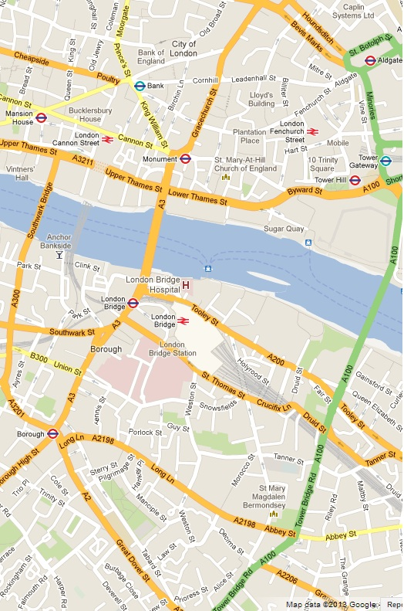
St Helen’s Church,
Bishopgate

London Bridge Rail and Underground Station
St Christopher’s Inn

CMF Office:
6 Marshalsea Road,
SE1 1HL

