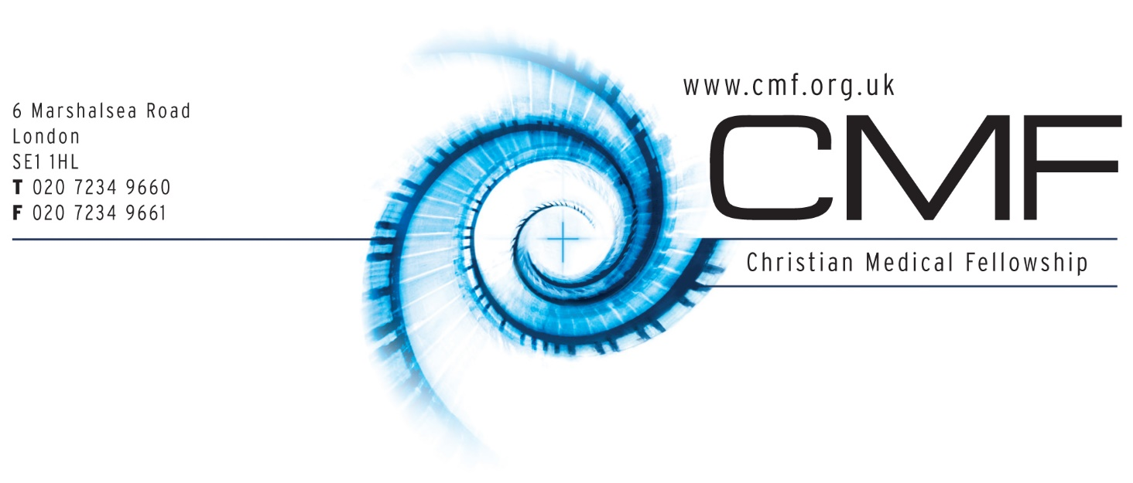

APPLICATION FORM
for a volunteer role

STRICTLY PRIVATE AND CONFIDENTIAL

                - Please answer the questions as fully as possible, giving examples where appropriate. If you are unable to comment on any area, please say so, and indicate the reason why.

POSITION APPLIED FOR:

PERSONAL DETAILS
Surname |  |  |  |  | Title
First name
Address

Telephone: |  |  | Mobile:
Email address

EDUCATION
(Continue onto a new sheet if necessary)
From | To | School, University, College | Degrees, diplomas, or other qualifications

OTHER RELEVANT QUALIFICATIONS OR TRAINING COURSES ATTENDED
(Continue onto a new sheet if necessary)
Date | Course /Qualification

                - HEALTH RECORD
A disability or health problem does not preclude full consideration for the job and applications from disabled people are welcome. Our office has wheelchair access. All information will be confidential.

What illness of any consequence have you had over the last three years?

CURRENT EMPLOYMENT (or Study)
Current Post Title (or year of study):

Employer's (or University) Name and Address:

Part/full time:
Brief Description of Key Achievements in this and previous employments (or periods of study)

Why would you like to be involved with this ministry?

List any type of voluntary experience

What has been your previous involvement with CMF?

List any information or other experiences relevant to a volunteer position with CMF (e.g. special training, leadership)

List three events/accomplishments in your life that you have found fulfilling.
Exclude commitment to Christ, marriage, having children, graduating from university.
Examples: 1). I took care of our horse for one summer when I was 10. 2). I chaired the BMA Local Medical Committee for 4 years. 3). I volunteered on a short term missions trip to Bali and did 200 cataract operations.

Please describe your past and present spiritual journey with God

Work/study Outside of CMF
What will your week look like outside of CMF?

Are you in agreement with CMF's statement of faith? | Yes/No

Church Affiliation
Name of Church:
Denomination:
Attended for how long?
What role do you play in your church?

REFERENCES

Please give names and addresses of two people who are willing to act as referees, and who have known you for at least the past two years.

Reference 1: Church Pastor/Minister/Leader
Church Name:
Referee Name:
Position Held:
Church Address:

Telephone: | E-mail:

Reference 2:
Referee Name:
Relationship with candidate:
Home Address:

Telephone: | E-mail:

DECLARATION
I affirm that the information contained on this application is true. I consent to the use of this information during the recruitment process and during the volunteer period, if I am successful.

Signed: |  | Date:

                - Having completed and saved this form, please email it to: volunteer@cmf.org.uk and we will acknowledge receipt by return email.
                - If you have any questions about the completion of this form please email or call 020 7234 9663.

Mission Statement

The Christian Medical Fellowship unites and equips Christian doctors and nurses to live and speak for Jesus Christ

Key Aims

- Discipleship - to unite Christian doctors and medical students in Christ and encourage them to deepen their faith, live like Christ and serve him obediently, particularly through acting competently and with compassion in their medical practice.
- Evangelism - to encourage Christian doctors and medical students to be witnesses for Christ amongst all those they meet.
- Mission - to mobilise and support all Christian doctors, medical students and other health care students and professionals, in serving Christ throughout the world.
- Values - to promote Christian values in society, especially, but not limited to, the areas of bioethics and healthcare.

Statement of Faith

- There is one God in three persons, the Father, the Son and the Holy Spirit.
- God is sovereign in creation, revelation, redemption and final judgement.
- The Bible, as originally given, is the inspired and infallible Word of God. It is the supreme authority in all matters of belief and behaviour.
- Since the fall, the whole of humankind is sinful and guilty, so that everyone is subject to God's wrath and condemnation.
- The Lord Jesus Christ, God's incarnate Son, is fully God; he was born of a virgin; his humanity is real and sinless; he died on the cross, was raised bodily from death and is now reigning over heaven and earth.
- Sinful human beings are redeemed from the guilt, penalty and power of sin only through the sacrificial death once and for all time of their representative and substitute, Jesus Christ, the only mediator between them and God.
- Those who believe in Christ are pardoned all their sins and accepted in God's sight only because of the righteousness of Christ credited to them; this justification is God's act of undeserved mercy, received solely by trust in him and not by their own efforts.
- The Holy Spirit alone makes the work of Christ effective to individual sinners, enabling them to turn to God from their sin and to trust in Jesus Christ.
- The Holy Spirit lives in all those he has regenerated. He makes them increasingly Christ-like in character and behaviour and gives them power for their witness in the world.
- The one holy universal church is the Body of Christ, to which all true believers belong.
- The Lord Jesus Christ will return in person, to judge everyone, to execute God's just condemnation on those who have not repented and to receive the redeemed to eternal glory.

